4.7 I respond to problems with collaborative technologies



[The above photo shows the HP forum]

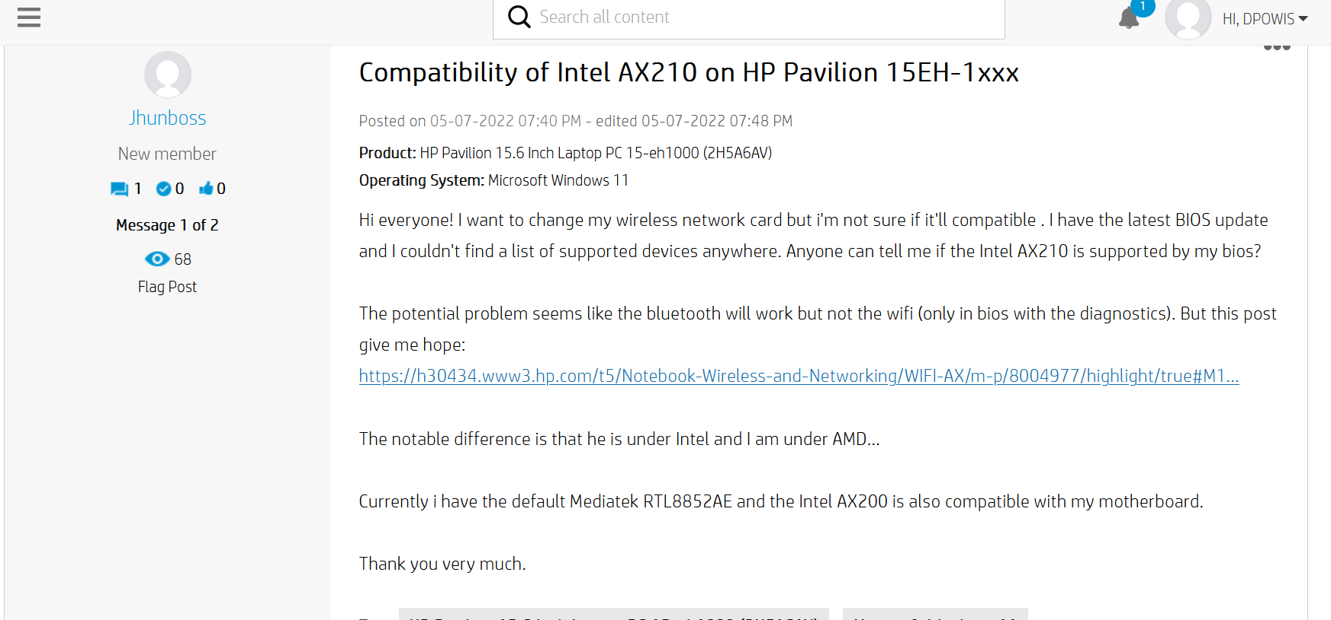

[The above photo shows a problem I found on the HP Forum]



[The above photo shows that I have replied to the post]

I found a problem on HP forum and with my knowledge of working with BIOS and software I advised the person to be cautious when installing something that wouldn’t be compatible with their computer as it may stop functioning.